GB-800 Synthesizer Programmer

Version 1.0 BETA

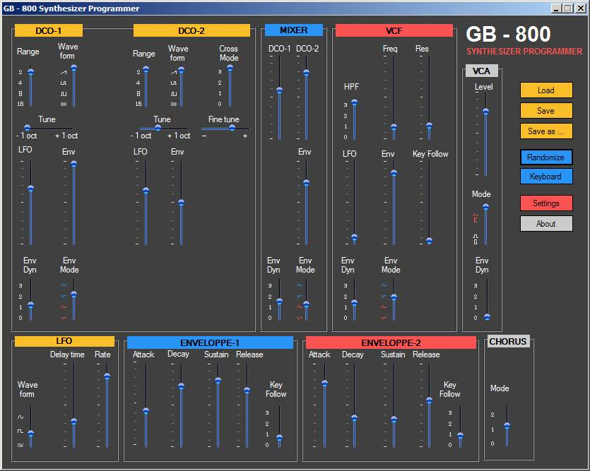

Introduction 3
Notice 3
Software requirements 3
Hardware requirements 3
Installation 4
Main view 4
Settings 5
The MIDI ports 5
Basic mode: using GB-800 as a standard PG-800 5
Advanced mode: Basic mode + MIDI input automation 5
Expert mode: Advanced mode + MIDI output automation 6
The automation table 7
The SysEx settings 7
Synthesizer type 7
Delay between SysEx 7
Troubleshooting and support 7

Introduction

The GB-800 Synthesizer Programmer is a software emulation of the Roland PG-800 Synthesizer Programmer. It provides additional features:
- Load/save tone SysEx from disk
- Ability to load tone SysEx without the need to have a Roland M-16C and/or M-64C memory cartridge in your synth
- Fully configurable real-time MIDI remote automation (IN and OUT), from any MIDI-capable Digital Audio Workstation (DAW) like Cubase, FL Studio, etc…
- Randomized tone generation
- MIDI SysEx timing configuration
- Virtual keyboard

This software is donationware. This means that you are kindly asked to send some money to the author if you use it. You are free to choose the amount of the donation yourself depending on how useful you find it. Go to the author website (http://greg-baumont.com) and click the Paypal™ donation icon.

Notice
THE SOFTWARE IS PROVIDED "AS IS", WITHOUT WARRANTY OF ANY KIND, EXPRESS OR IMPLIED, INCLUDING BUT NOT LIMITED TO THE WARRANTIES OF MERCHANTABILITY, FITNESS FOR A PARTICULAR PURPOSE AND NONINFRINGEMENT. IN NO EVENT SHALL THE AUTHORS OR COPYRIGHT HOLDERS BE LIABLE FOR ANY CLAIM, DAMAGES OR OTHER LIABILITY, WHETHER IN AN ACTION OF CONTRACT, TORT OR OTHERWISE, ARISING FROM, OUT OF OR IN CONNECTION WITH THE SOFTWARE OR THE USE OR OTHER DEALINGS IN THE SOFTWARE.

Software requirements
- Microsoft .NET Framework 2.0 (http://www.microsoft.com/downloads/details.aspx?FamilyID=0856eacb-4362-4b0d-8edd-aab15c5e04f5&displaylang=en) or .NET Framework 2.0 + SP1 (http://www.microsoft.com/downloads/details.aspx?familyid=79BC3B77-E02C-4AD3-AACF-A7633F706BA5&displaylang=en).
- A MIDI virtual cable driver (to use the MIDI remote automation feature). MIDI Yoke (http://www.midiox.com/index.htm?http://www.midiox.com/myoke.htm) is free and works fine.

Hardware requirements
- JX-10, MKS-70, or JX-8P synthesizer.
- A MIDI interface with at least one MIDI output port.

For JX-10 synthesizers, you will need the JX-10 firmware update from Colin Fraser. (http://www.colinfraser.com/jx10/jx.htm)
From Colin web site: "This firmware allows editing of the currently active tone via MIDI. That is, if you are using Dual or Split mode, the Tone that is currently active for editing (the one with the dot by the number) will be modified by the SysEx. The command format is the same as that used by the MKS-70 rack version of the JX-10."

The GB-800 Synthesizer Programmer will not work with the JX-10 without this update.
Please note that the GB-800 Synthesizer Programmer has nothing to do with Colin Fraser, so please don't bother him with questions about it.

Please note that software tests were made only with the JX-10 ( the author is not rich enough to have all these 3 synthesizers together ;) ) and Windows XP SP3. Specific MKS-70 and JX-8P implementation follows the MIDI specifications of these synthesizers.

Installation
Please install the .NET Framework (if not already installed on your system), and the MIDI virtual cable driver (only if you want to use the MIDI remote automation feature). Reboot may be required.

Unzip the archive containing the application and launch the “GB800 Programmer.exe” application.

Before using the software, please read carefully the following chapters to understand the features of the GB-800 Synthesizer Programmer and how to configure it.
At least, read how to set up the output MIDI port and the synthesizer type in the settings.

Main view

The main view is composed of the sliders available on the PG-800 programmer. Each slider controls the corresponding parameter. When the remote automation is configured, sliders movements follow the received values.
When moving a slider, a tool tip shows on top of the slider the value sent to the synthesizer. This value is the SysEx parameter value (0-127 range).

The other commands are straightforward:
- Load/Save/Save as: tone SysEx load/save/save as. Please note that the save command will not save the SysEx into the synthesizer memory, but the tone SysEx file on the disk. If you want to save the tone into the synthesiser memory, use the “Write” button on the synthesizer itself.
Note: Cartridge SysEx dumps and patch SysEx files are not supported.
- Randomize: this will generate a tone with randomized values for all parameters (but the VCA Level that is kept to 100 in order to get an audible sound).
- Keyboard: This command shows/hides a virtual keyboard to play notes with your synth without the need of a real MIDI keyboard.
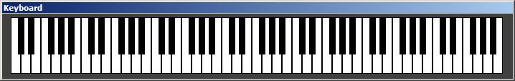

- Settings: Opens the settings dialog box (see the following chapter)
- About: shows the about box.

Settings

The MIDI ports

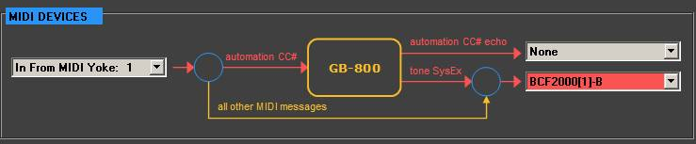

You can use the GB-800 Synthesizer Programmer in 3 different modes. We will call them Basic, Advanced and Expert mode. The following chapters explain these modes and how to configure the MIDI ports to use these modes.

Basic mode: using GB-800 as a standard PG-800
This mode is mainly used when you don’t use your DAW and the MIDI automation capabilities. You use the GB-800 as a standard Roland PG-800. That is, moving a slider changes the corresponding parameter of the synthesizer. To enable this mode, you have to choose the MIDI output port on which your synth is connected to. This port is the red one on the picture below.
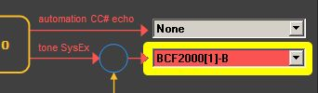

Advanced mode: Basic mode + MIDI input automation
In this mode, you can control each parameter of the GB-800 with external control change messages and use the GB-800 as a MIDI gateway. This is the most used mode.
To use this mode, you have to define the MIDI virtual cable input corresponding to the MIDI virtual cable output that you selected in your DAW. For example, you could choose the input of the first virtual port of MIDI Yoke, because you choosed the output of the first virtual port of MIDI Yoke in your DAW. If you find these explanations a bit fuzzy, please read the documentation of your MIDI virtual cable driver software.

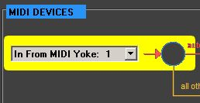
Each control change message mapped to a parameter through the automation table (see the “automation table” chapter) will control the corresponding parameter. All other MIDI messages will be sent to the synthesizer.
For example, if you set in the automation table the control change #1 (modulation) to control the VCF Freq parameter, you can play notes on your MIDI Keyboard controller while changing the filter frequency with the modulation wheel.

Expert mode: Advanced mode + MIDI output automation
In this mode, you can record into your DAW the slider movements you do with your mouse on the GB-800 main view as CC# changes.
You can use this mode if your DAW does not provide an interactive way to record/draw CC# changes.
To use this mode, you have to define the MIDI virtual cable output corresponding to the MIDI virtual cable input that you selected in your DAW (see below). Again, if you find these explanations a bit fuzzy, please read again the documentation of your MIDI virtual cable driver software.
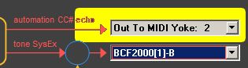
Note 1:
Please note that CC# changes that are coming in from the MIDI input defined for the advanced mode will not be sent back to the MIDI output defined for the expert mode (this is useless).

Note 2:
If you don’t want to record mouse moves, you don’t need to be in expert mode to record CC# changes that you do in your DAW. This is already handled by your DAW when you are recording MIDI events.

Note 3:
Be careful when choosing the output port. Do not use the same port number as the port number you choose for the MIDI input in advanced mode, since you will get an infinite MIDI loopback. Result may be unpredictable.

The automation table
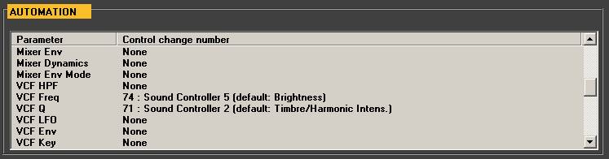

To assign a control change to a parameter, left-click on the corresponding line and choose the control change number in the combo box that appears. To remove an automation, choose “None” at the end of the combo box.
Please note that a Control Change can be assigned to more that one parameter.

For your convenience, you can export the whole automation table to an HTML document. Right-click on the table and choose “Export as HTML file”.

Changes in automation table take effect when the “OK” button of the settings dialog box is pressed.

The SysEx settings

Synthesizer type
Select the type of synthesizer you have. Wrong choice will result in no communication at all with your synthesizer.

Delay between SysEx
This value is the delay in milliseconds between each SysEx message sent to the synthesizer. If you get a mangled sound when loading a tone SysEx file, try to increase this value.
20 ms should be sufficient for a JX-10 synth. The lower the value is, the more “real time” is the control of the parameters. Keep in mind that very low values (1 or 2 ms) may result in bad sound or even in synthesizer “freeze”.

Troubleshooting and support

- Q: In advanced automation mode, I still get messages sent to my synthesizer a couple of seconds after I stop to play MIDI in my DAW. CPU load of the GB-800 software is important. Why ?
- A: Depending of the MIDI resolution (“PPQN” value) used in your DAW, it can send a big amount of control changes messages to its MIDI ports. The GB-800 software has to handle every single message, to check if the value is different from the previous one, and if not, enqueue this message in an internal queue in order to send it to the synth. Since a delay exists between each message sent to the synthesizer the total amount of awaiting messages can be significant and thus the delay. Try to reduce the MIDI resolution of your DAW (the lowest is the best, try 24 if possible or up to 96. More than 192 is really not a good idea, 768 will result in high CPU load and big latency).

For support, please send an email in English/French/German to gb800support(at)free.fr, describing your problem accurately and the following information:
- Operating system, version and service pack
- .NET framework version and service pack
- Version of the GB-800 synthesizer programmer software (see the about box)
- Name and version of the virtual MIDI cable driver you use
- DAW name and version
- MIDI interface you used

Even if the author spent days to develop this software, please keep in mind that it is still in BETA version.

Greg Baumont (Pascal Schmitt).
http://greg-baumont.com

PG-800, JX-10, MKS-70, JX-8P, M-16C and M-64C are trademarks of Roland Corp.
Cubase is a trademark of Steinberg
FL Studio is a trademark of Image Line Software

